This year Circleville City School Foundation sponsored 16 student scholarships for Circleville City Schools students to attend “Kids on Campus”; a summer enrichment program at Ohio University Campus for Pickaway County students in grades 1-4. Students engaged in hands-on learning and activities that focus on exploration and investigation.
These pictures show students in classes taught by Amy Happenny (math), Rolanda Hurtt (science), Ashlee Engel (technology) Amanda Patterson (visual arts) and new this year Linda Huff(music).
Christy Mills, Pickaway County H.E.L.P.S. (Higher Education Learning Partners for Students) coordinator, says that in the tenth year of this program being held at Ohio Christian University that the enrollment of 285 students is at an all-time high. In 2007, the program began with an enrollment of 19 students. The goal of the Circleville City Schools Foundation is to continue to encourage and sponsor students to attend this worthwhile, effective program.
Exploring Technology

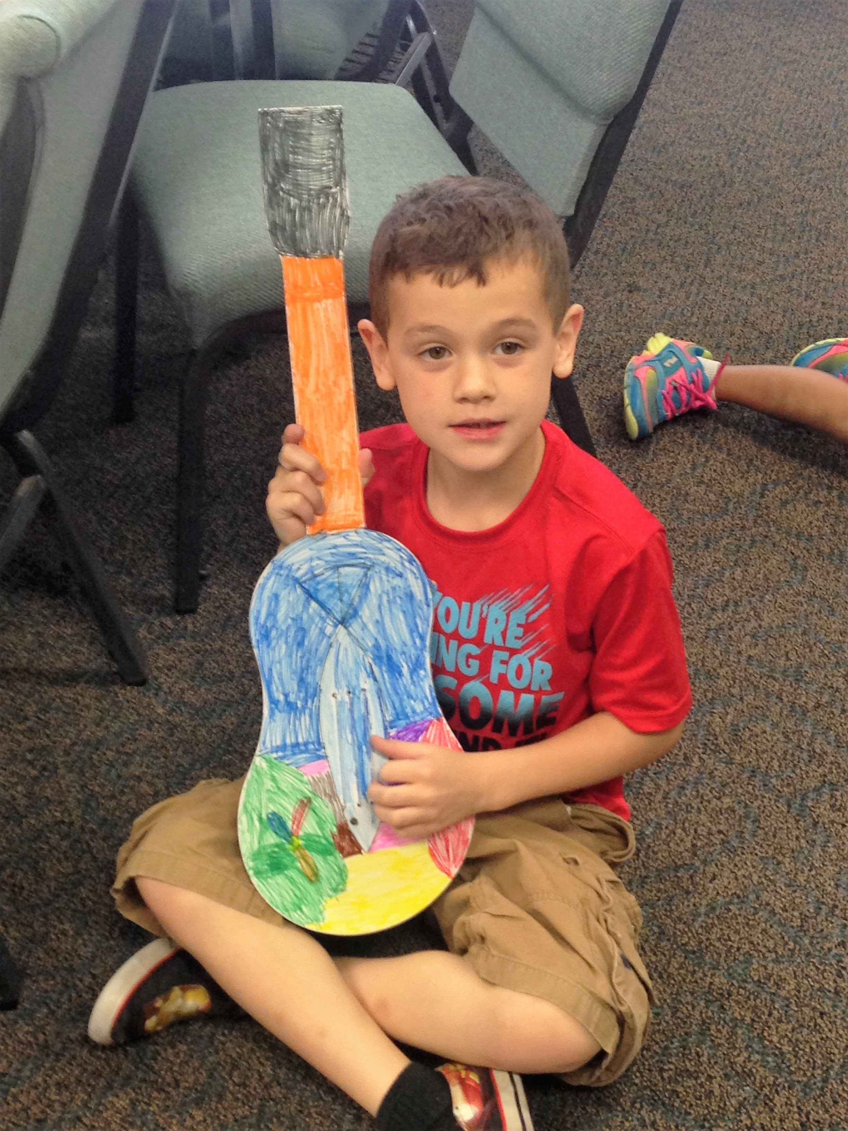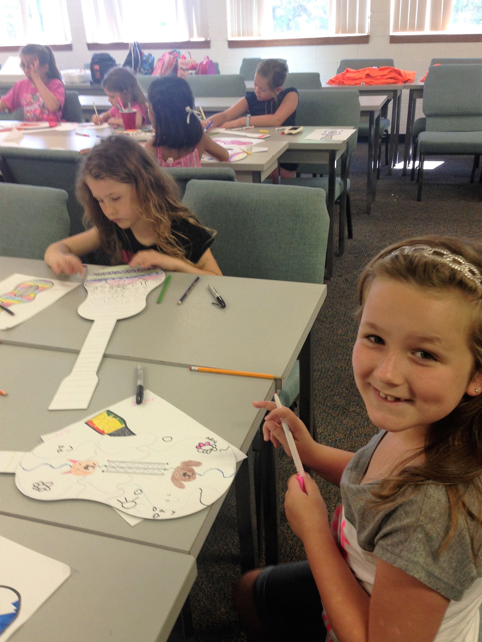
Creating Masterpieces
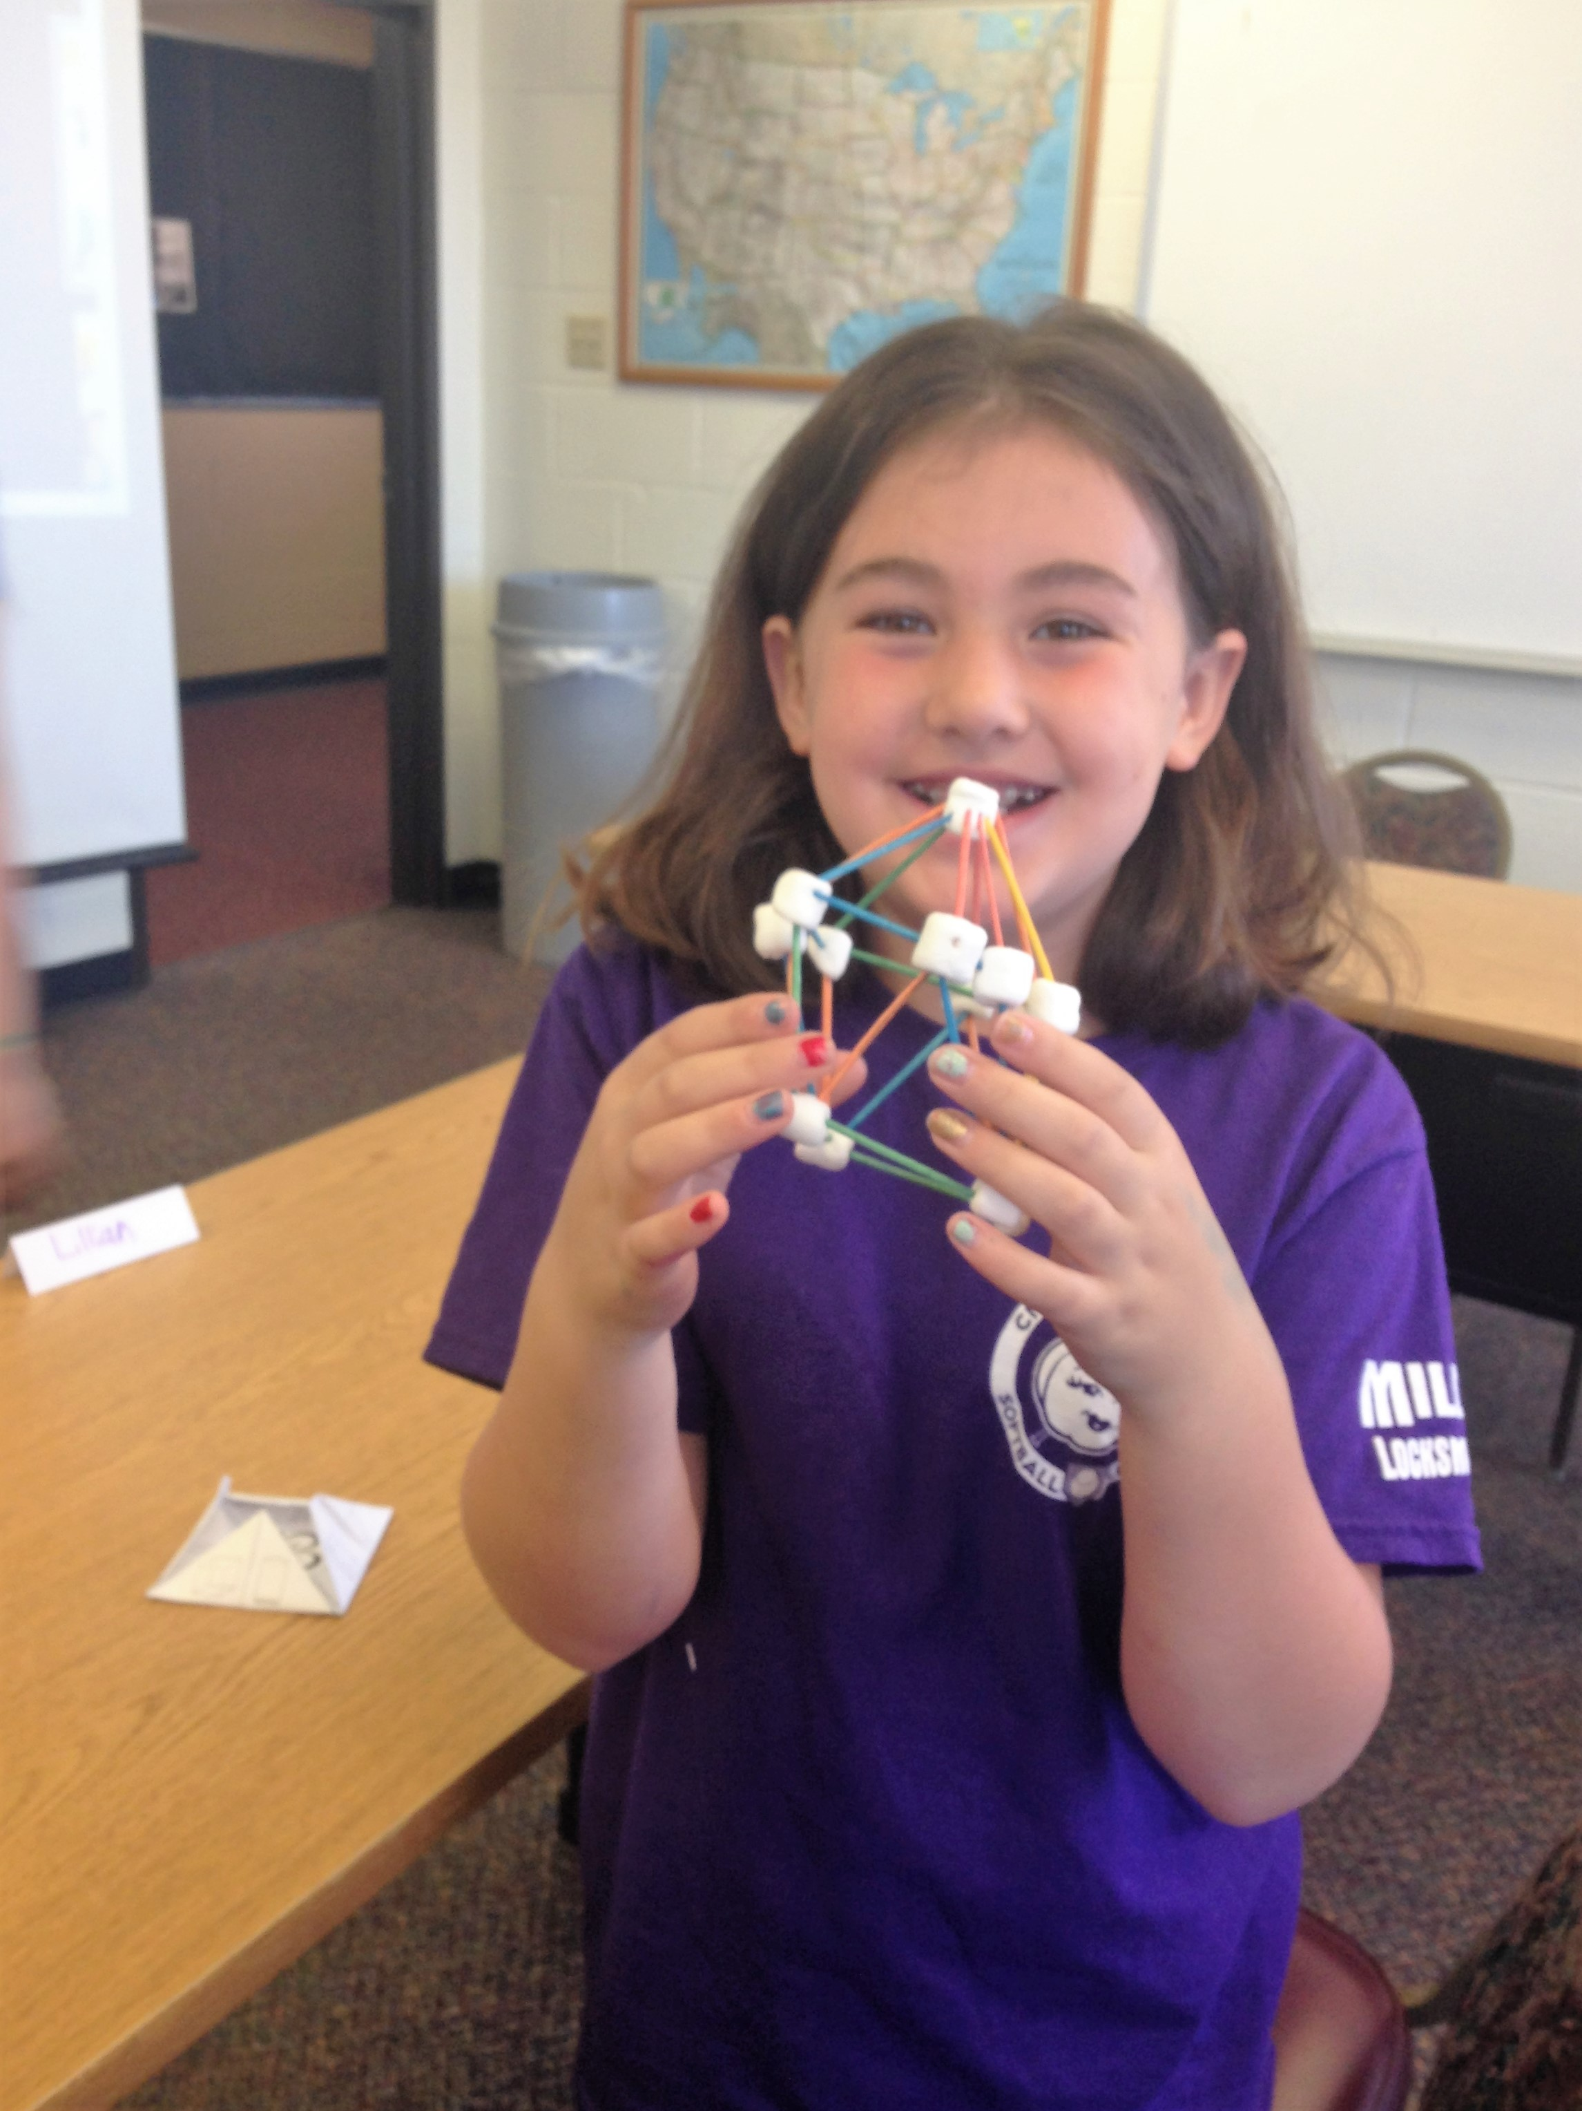
3-D shape math experience
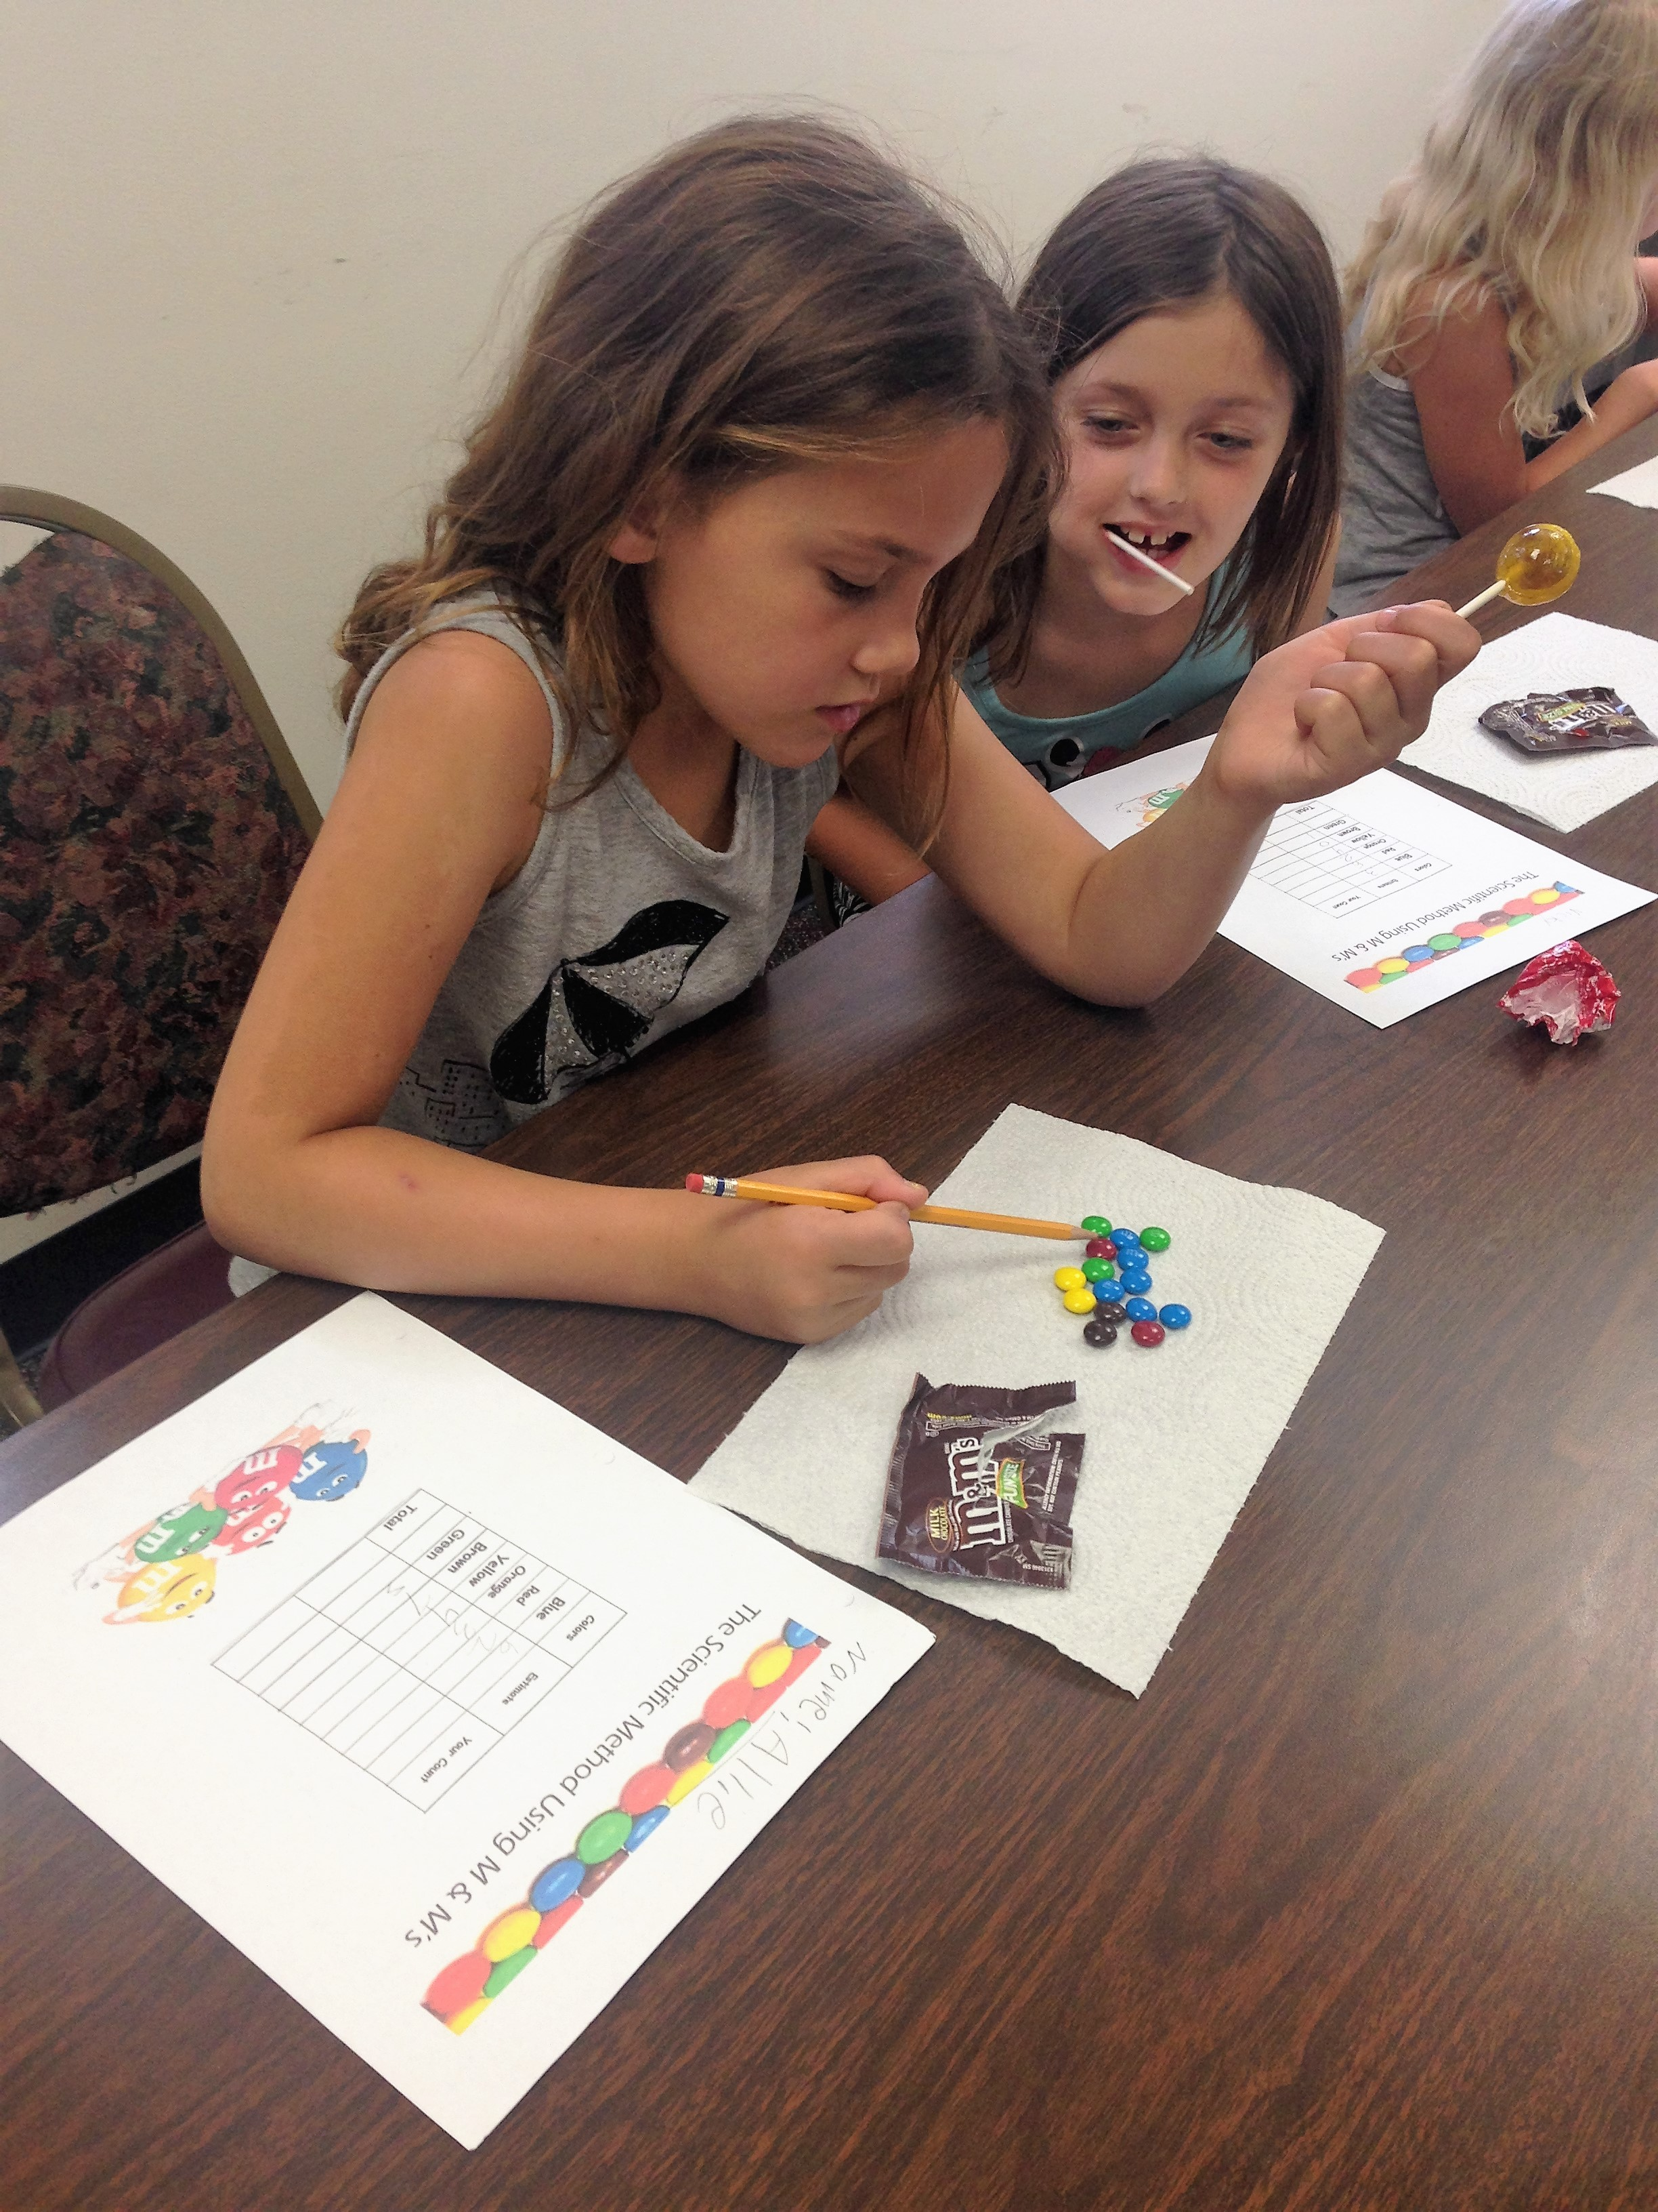
Learning Scientific Methods with M & M’s
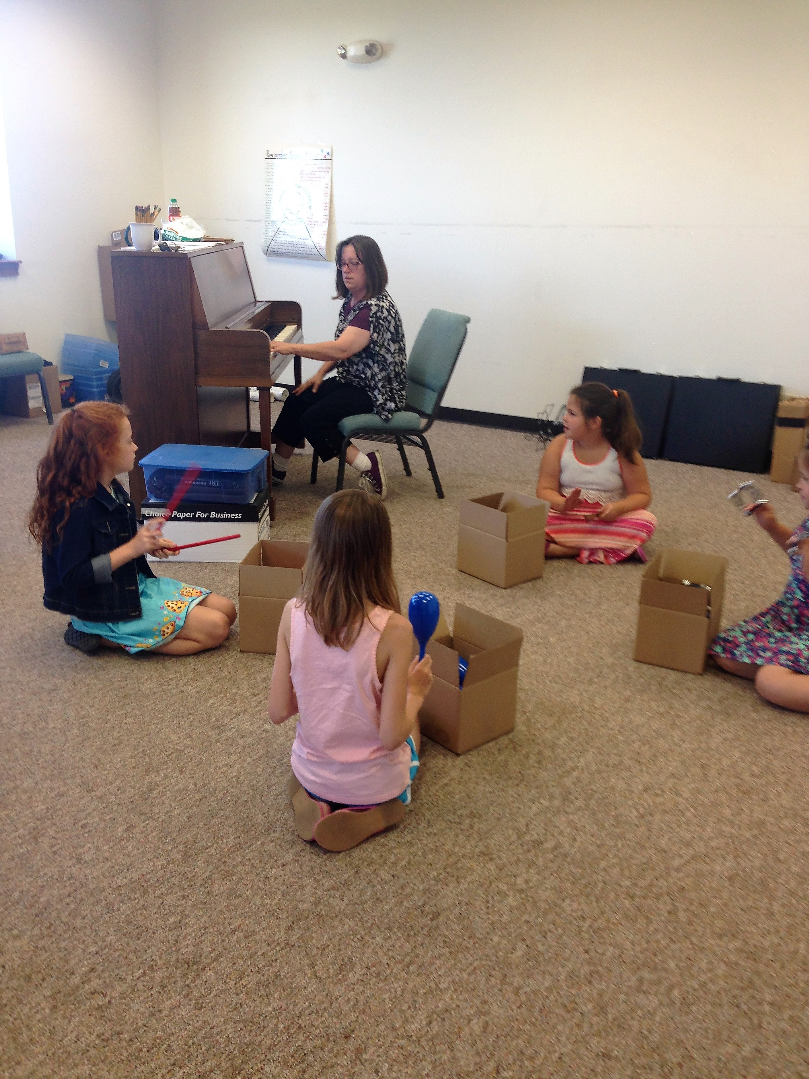
Experiencing musical rhythm and tempo

